Seminar Report on In-Vehicle Networking for Electric Vehicle Technology

IAS Kerala chapter&IIST IEEE IIAS student branch chapter

11th April, 2018 3:00PM

A Seminar talk on “In-vehicle networking for EV technology” was organized by IEEE Industry Application Society Student branch chapter-Indian Institute of Space Science and Technology (I.I.S.T) at 3.00 p.m on 11th April 2018 at Science block (D2), I.I.S.T campus. The seminar talk was given by Mr Sigi C. Joseph, Principal Engineer, Power Electronics group, Centre for Development of advanced Computing (C-DAC), Trivandrum. IEEE I.I.S.T Student branch chairman Pranav Kumar Singh welcomed the participants to the program. The program was chaired by Dr. Sudharshan Kaarthik, IEEE Industry Applications Society (IAS) student branch chapter Advisor and Assistant Professor of Avionics Department I.I.S.T.

Dr. Sudharshan Kaarthik introduced the speaker to the audience. The speaker started the seminar talk by giving a brief introduction about the organization C-DAC and its current research activities in the field of power electronics. Then the main content of the talk – In-Vehicle Networking for EV and EV Charging based on SAE J1772 standard was covered. The program also included an interactive session after the talk, during which the participants cleared their doubts regarding the topic covered in the talk. The interactive session was followed by vote of thanks. IEEE IAS Student branch chair Prasoon Chandran Mavila delivered the vote of thanks. He also mentioned about the importance of IAS briefly and welcomed the interested participants to become a part of IAS SB IIST. Dr. Sudharshan Kaarthik presented a memento to the speaker on behalf of IEEE Student branch IIST and the program was disclosed at 5.00 p.m. Total 45 participants including students and professors attended the program. Participation Certificates were distributed after the program.

General Awareness about C-DAC

C-DAC (Centre for Development of advanced Computing) is a Multi-Activity R&D organization. It is involved in the design, development and deployment of electronics and advanced Information Technology products and solutions and works in the fields of power electronics, control and communication, strategic electronics etc. The Power electronics group of CDAC works on multilevel inverters, Distributed generation, UPS Drivers, EV/HEV, PQ solutions and SMPS. The projects also comes under the National Mission on Power Electronics Technology (NaMPET) sponsored by Ministry of electronics and information technology (MeitY) of Govt. of India.

EV Projects undertaken by C-DAC

CDAC has been working in the field of HEVs since 1999. The series hybrid EV project; consisting of design and development of a hybrid EV from 1999 to 2004. During 2004-2007 CDAC had worked in the development of three wheeler series hybrid electric vehicles. The other major projects include hybrid on board battery charger for Renault Nissan technology business center, Vehicle control unit and Train communication network for Indian railways.

In-Vehicle Networking

The main content of the talk was started with a discussion on the block diagrams of series HEV and distributed control in HEV. The various electrical systems inside the EVs (for Eg. Propulsion motor controller, Battery charge controller etc.) Require real time communication of various parameters for

its effective working. So it necessitates the requirement for efficient data transfer systems inside the vehicle. The data transfer includes parametric data exchange such as voltage/current levels of the converter systems, speed – torque details , acceleration pedal readings etc. and logical data exchange such as status of controllers, start stop commands of systems, emergency commands etc. C-DAC has used controller area networking (CAN) for its EV implementations which efficiently supports distributed real time control applications. The CAN system in the OSI network model and CANopen application protocol was discussed. The overview of CAN Data transfer and controller architecture for PE was also mentioned.

EV charging-J1772

The availability of Chargers- Electric Vehicle Supply Equipment (EVSE) is one of the key factors contributing to the market penetration of EV. SAE surface vehicle recommended practice J1772 standard constitutes a definition of how a charging station connects with, communicates with and charges the EV. It can be thought as a smart outlet that communicates with the vehicle to “handshake” and ensure safe charging. It also deals with general physical requirements, electrical specifications and performance requirements. The charging levels were discussed. The J1772 pilot signal enables the communication of EV and EVSE. The communication happens through the modulation of voltage levels of the signal as well as the duty ratio. The talk also covered the details of GFCI-ground fault circuit interrupter and stuck relay detection.

Interactive session with the audience

The talk was followed by an interactive session for the participants. The main challenges in bringing EVs to Indian transportation market were discussed. Participants asked about the existence of several standards and protocols instead of a single standard protocol in the EV communication systems. The challenges that will be faced by the electrical grid due to the proliferation of EVs and EV charging stations are a main concern that needs to be taken care of. Participants also asked about the ability of in-vehicle communication systems in indicating and avoiding the possible faults inside the EVs.
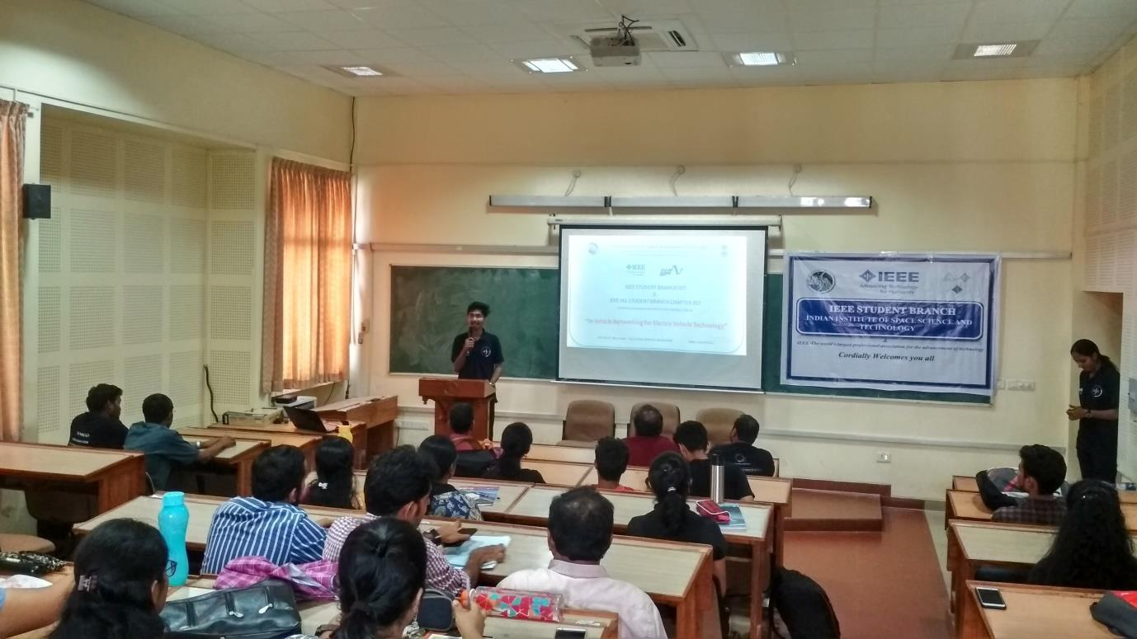

IEEE SB IIST Chair Pranav Kumar Singh welcoming the participants and delegates

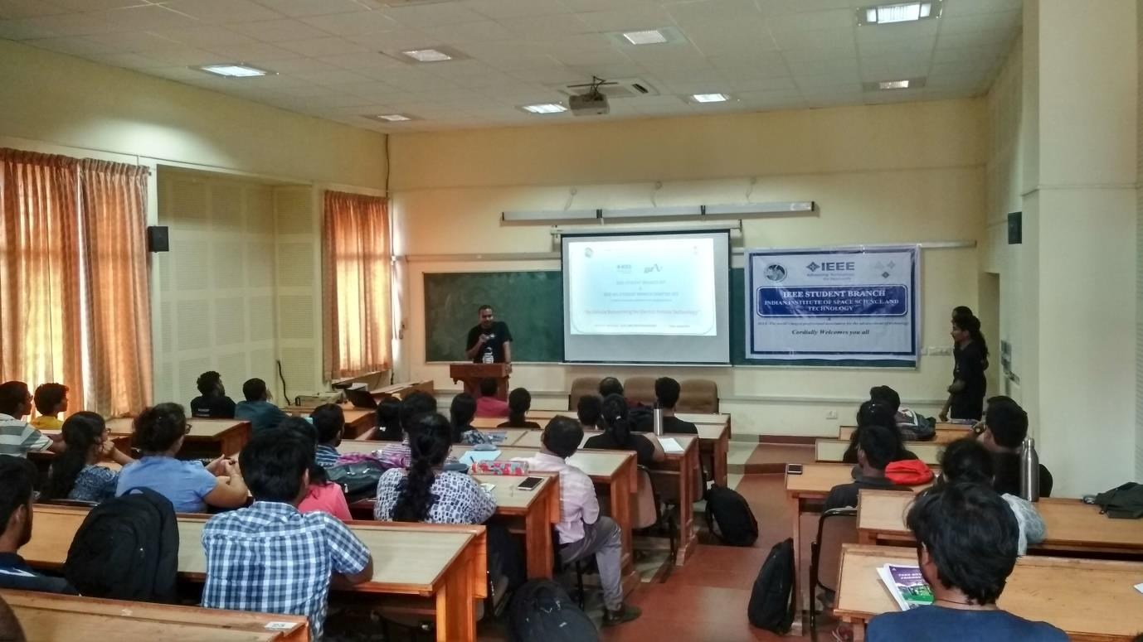

IEEE IAS SB chapter Advisor Dr. Sudharshan Kaarthik delivering Keynote address
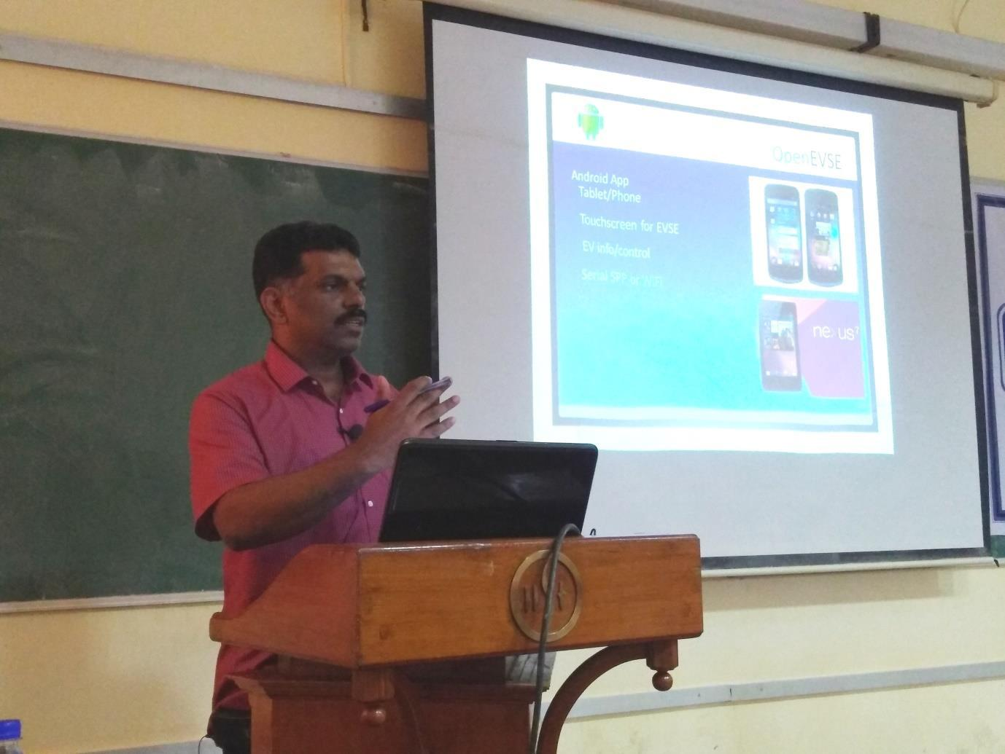

Mr Sigi C. Joseph (Principal Engineer- PE division C-DAC) giving the expert talk

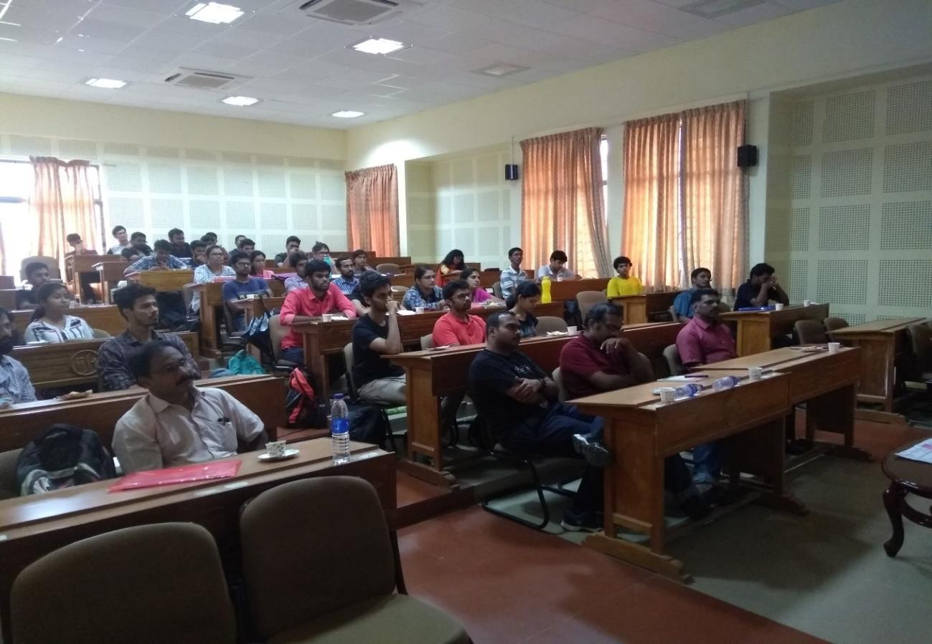

The audience of the talk.
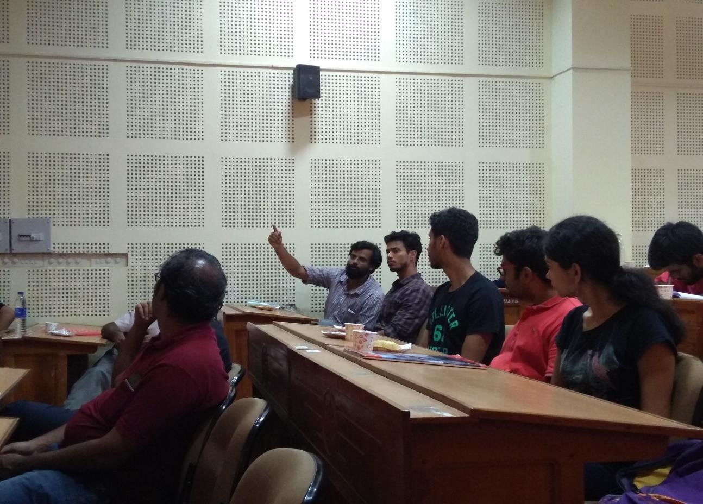

Interactive session after the talk

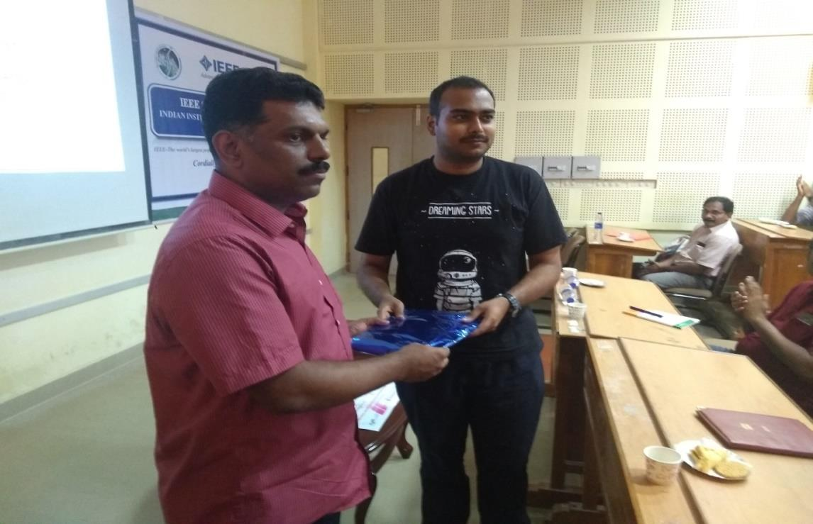

IEEE IAS SB chapter Advisor Dr. Sudharshan Kaarthik presenting a memento to the speaker.
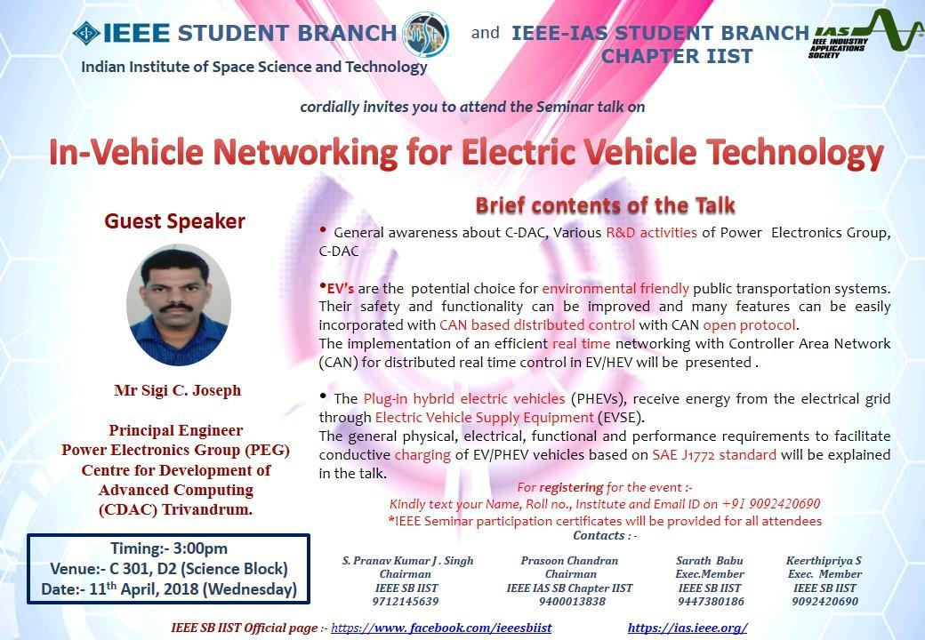

Event poster

Report prepared by Mr. Prasoon Mavila, Chairman, IIST-IEEE IAS SB Chapter, Kerala.

