IEEE WIE ANNUAL GENERAL BODY MEETING 2018-REPORT
Date: 10th June 2018
Venue: Aashir Bhavan Kochi

IEEE Kerala Section WIE Annual General body meeting 2018 was held on 10th June 2018 at Aashir Bhavan Kochi. The program was inaugurated by watering a plant at 10.45am. The event had participation from of 68 students spread across 3 hubs.

The whole program was anchored by Ms. Ayisha Naziya, Kerala Section WIE Secretary. Inaugural Speech was given by Ms. Saradha Menon. She included STAR programs WIEWAVE and STEM (an article on Economic Times) in her speech. Ms.Mini Ulanat, Chaiperson, WIE Kerala Section also addressed the gathering.

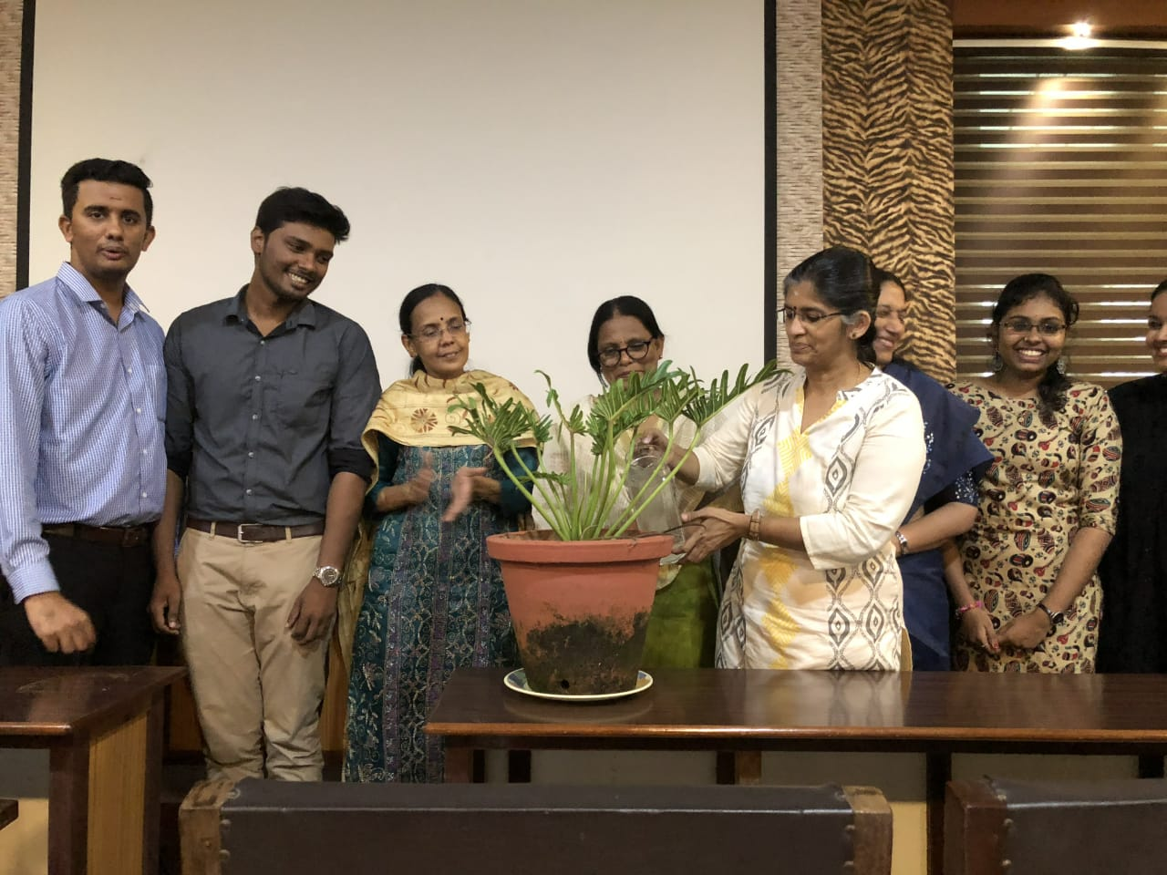

Ms.Sharadha Menon Inaugurating the event by watering the plant

The meeting was followed by a self-introduction session. Ms Ayisha asked all the representatives to share their experiences in IEEE and the reason for joining IEEE and WIE. Variety of answers from the gathering made the meeting quite live. A break of 20 minutes was given at 12.00PM.

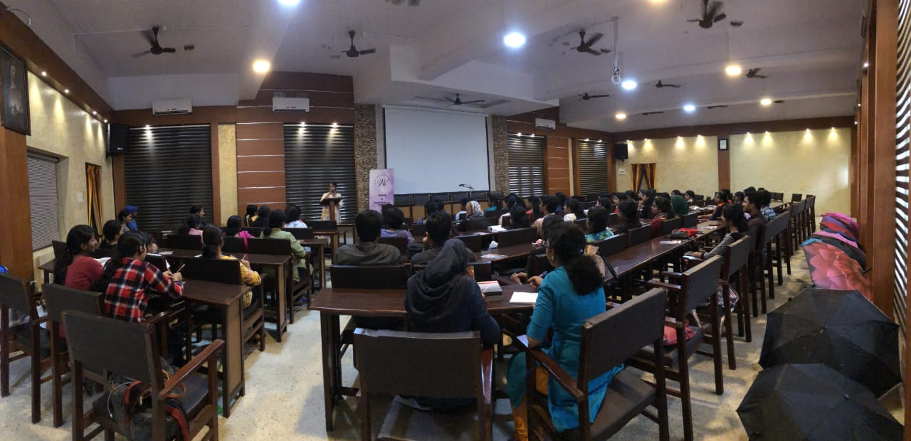

A photo taken during the AGM

After the break Mr. Sabarinath Pillai, Student Activity Chair of Kerala Section shared his experience in IEEE.
Ms. Mini, WIE Kerala Section Chairperson delivered her experiences and told that Students in India were fortunate for the immense opportunities they have, to get into engineering field compared to others. Sankara Nayaki K, Computer Society Chapter Counselor, Ms. Remya K,WIE Advisor,
Ms. Laali Joseph , Vice Chairperson of WIE Kerala Section also shared their experiences in IEEE and Engineering .

Vijay, a senior IEEE member and a former student of MES Kuttippuram shared his experiences in IEEE. He mentioned about the glories of Kerala section outside India as he is now residing in Australia. This was followed by the experience sharing of Mr.Renjith R Nair, IEEE Kerala Section MDC. He said that Kerala Section is in the first position in terms of membership with 1870 members among which 1600+ are student members. He advised that IEEE membership is beneficial only if one could utilize the opportunities. He also indicated the need for hosting a new website for WIE including the historical information . This was followed by the lunch break from 2.00PM to 2.45PM.

After the lunch, Ms.Ayisha explained about IEEE Women in Engineering International Leadership Summit (ILS )2018 which is going to be held in Le-Meridian Kochi on September 7th &8th 2018. Speakers who were selected to be a part of ILS Kochi were declared. She also included the need of women in technical side than managerial ones as they faced difficulty in getting women volunteers for technical support and information regarding how one can be a part of ILS Kochi as a volunteer or delegate was also shared
Staji, WIE coordinator LINK gave a summary of various programs conducted in Kerala under WIE last year. Mini Ulanat and Mr. Sahil Sameer (Kochi Hub HSR) shared valuable informations on the scholarships and funds provided by IEEE for innovative and humanitarian ideas. Feedbacks were collected from two members from each hub and everyone shared their suggestions for ILS Kochi .
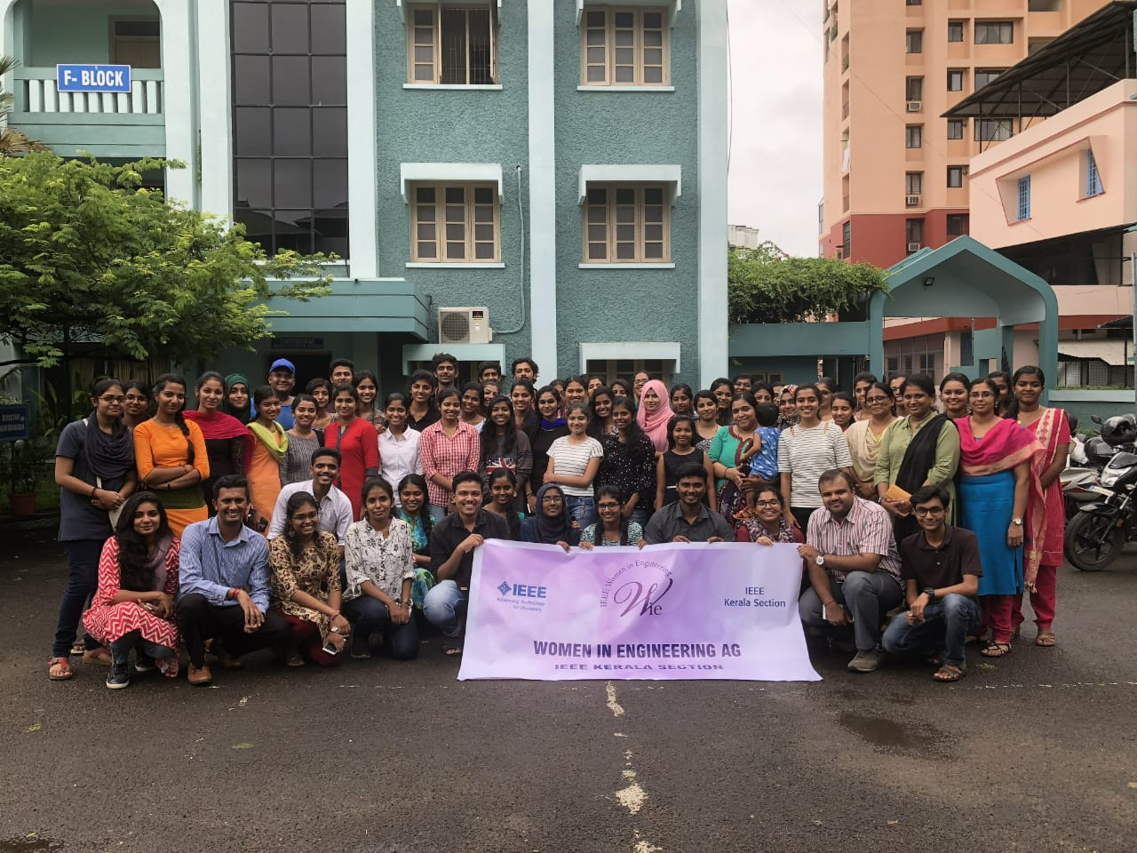

Team WiE

The program came to an end by 3.30PM after the Vote of Thanks by Ms. Laali Joseph, Vice chairperson WIE Kerala Section.

